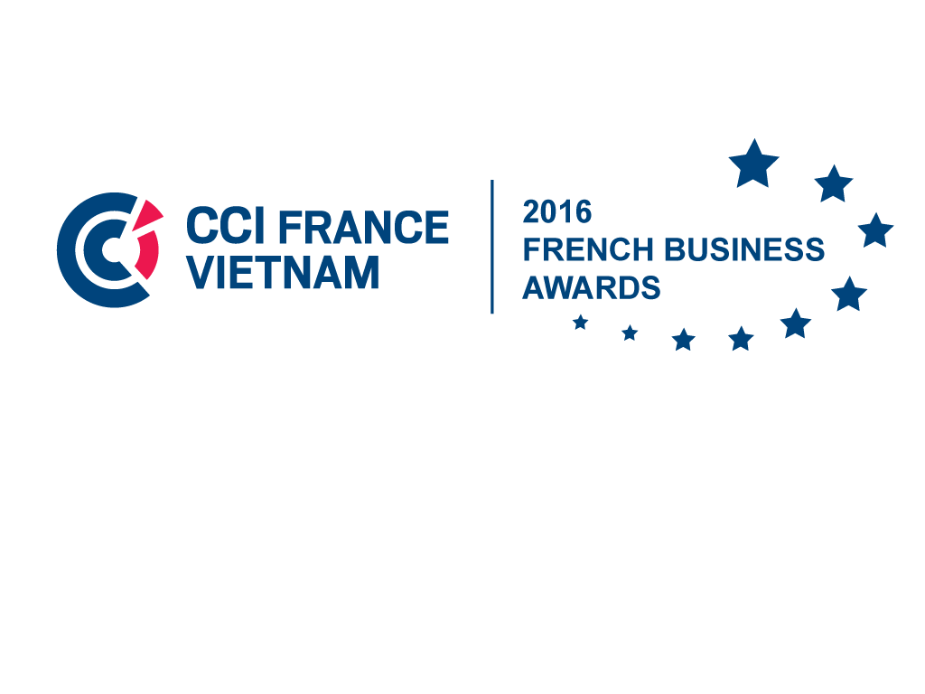

French Business Awards 2016

Given the success of the first two editions of the French Business Awards, which were launched for the first time in April 2013 to mark the Year of France in Vietnam, the French Chamber of Commerce and Industry in Vietnam (CCIFV) is pleased to present the third edition of the event.

- In a few words…
The French Business Awards is a competition organized by the CCIFV, aiming to highlight French companies and businessmen in Vietnam.
The awards ceremony will take place on January, 14th 2016 and will reward the winners of the 4 following categories:
- Communication
- Sustainable Development
- Entrepreneur
- France-Alumni
Beyond highlighting the company itself, these awards are designed to show the dynamism of French entrepreneurs and/or French companies operating in Vietnam. By rewarding the most successful of them, they also value the know-how « à la française », the ability for innovation, integration and adaptation to the local market, the French contribution to foreign trade and more generally the contribution to the French influence at a local and regional level.
For entrepreneurs or companies that are candidates, participating in these awards is a real opportunity to show their vitality on the Vietnamese territory, to promote their business and to gain visibility. The winners of each category will also win an incentive prize in addition to a symbolic trophy.
This year, the Awards Ceremony will reservedly take place in the presence of the French Ambassador in Vietnam.

- Application criteria

The competition is open to every company set up in Vietnam, member or not member of the CCIFV and whatever their legal form, showing a relevant link with France.
Some categories might have additional criteria.
- Awards presentation

  - « Communication » Award (new category)

This award is for all the companies regardless of their size and meeting general application criteria
The « Communication » Award rewards a company in its ability to conduct a successful and original campaign (any customer audience, any media).
Criteria:
- Creativity : originality, ability to product and share a message, visibility
- Effectiveness: development execution and results to date
- Marketing: brand image and promotion
- Presentation of the application file

  - « Sustainable Development » Award

This award is for all the companies regardless of their size and meeting general application criteria
The « Sustainable Development » Award rewards a company in its initiative to implement sustainable development projects.
Criteria:
- Sustainable development share in the company’s strategy: ethical charter, annual report on sustainable development, integration of social and environmental standards
- Implementation and impact of projects: initiative taking, number of projects, relevance, evaluation measure, impact
- Economic nature of the project: development of know-how and / or products and services, wealth creation, number of jobs created.
- Presentation of the application file

  - « Entrepreneur » Award

Individuals or companies with less than 3 years of activity, which are not subsidiaries of existing companies and meeting general criteria
The « Entrepreneur» Award rewards an individual or a company for their ability to have created and developed a new business in Vietnam.
Criteria:
- Business evolution: relevance of business model, growth evolution, number of employees, reputation of the company, company’s ability to grow up
- Entrepreneurial qualities: qualities in growing and developing the business, continuous tenacity and determination to overcome challenges
- Integration into the Vietnamese economy: projects and investment in Vietnam, understanding of the local market, supplier relationships, staff training, regional or international development
- Presentation of the application file

  - « France-Alumni » Award (new category)

This award is for all the companies regardless of their size led by and/or employing at least a Vietnamese person who studied in France (referred as France-Alumni), and meeting general application criteria
The « France-Alumni » Award rewards a company that highlights the outstanding achievements of a France-Alumni employee.
Criteria:
- HR policy towards Alumni
- The France-Alumni’s achievements: outstanding achievements or projects led within the company
- Presentation of the application file

Application steps
Candidates willing to register for the French Business Awards 2016 must prepare an application file for the award category of their choice. This application file includes a registration form and a Power Point presentation that have to be sent by email (see below the different deadlines).

Registration form (deadline for submissions on November 18th): Companies must fill in a registration form for the category they are candidate for (see below) to provide the organizers with their information and to explain their application.

Power Point Presentation (deadline for submissions on December 2nd): This year, in addition to the registration form, candidates must prepare a short Power Point presentation of 3 slides maximum to sum up their application (presentation of the company, relevance of the category choice, initiatives and/or achievements fitting with the category). The presentations of the nominated candidates of each category will be screened the day of the Awards Ceremony (animations are recommended).

Jury’s evaluation
Candidates will be given a mark for each criterion of their awards category and a mark for their Power Point presentation, and the jury will make an average of the marks (without coefficient).

For each category, the 3 candidates that will receive the best average will be nominated for the French Business Awards.

The announcement of the winners of each category will be made during the Awards Ceremony, on January 14th 2016.

Estimated calendar
October | Communication of the French Business Awards to companies (online) and opening of the applications
November 18th | Deadline for registration forms: end of registration forms submissions (by email) at 12am
December 2nd | Deadline for Power Point presentations: end of application files submissions (by email) at 12am
December 3rd | Submission of candidates' files (forms and files) to the jury
December 3rd to 17th | Meeting of the jury and deliberations (2nd possible deadline on December 28th if necessary)
January 14th | Announcement of the Awards winners, Awards Presentation Ceremony and Cocktail

French Business Awards 2016

Competition rules of procedure

Article 1: Objective of the competition
The French Business Awards 2016 is an event organized by the French Chamber of Commerce and Industry in Vietnam (CCIFV), aiming to promote and encourage the presence of French companies in Vietnam.
Four Awards will be awarded: Communication, Sustainable Development, Entrepreneur and France- Alumni Awards.
Article 2: Application conditions
The competition is open to every company set up in Vietnam, member or not member of the CCIFV and whatever their legal form, with a relevant link with France.
To apply for the competition, the companies shall meet general application criteria and specific application criteria that are proper to each awards category.
Article 3: Application files
The registration forms will be available on the CCIFV’s website from October 19th.
Candidates can only apply for one category.
A valid application requires the candidates to confirm their participation by sending their registration form to the following address: julie.nguyen@ccifv.org on November 18th noon (Vietnam time) at the latest.
To complete their application files, candidates must send a 3 slides Power Point Presentation to the following address: julie.nguyen@ccifv.org on December 2nd noon (Vietnam time) at the latest.
The deadline for submission of the application files is December 2nd noon (Vietnam time).
The Jury has the right to reject incomplete applications or applications that contain false information. They also can solicitate additional information.
Article 4: Communication
Candidate companies accept their name to be mentioned during communication actions of the event, including in the media.
Press releases will be published before and after the event. The names of the winners will not be made public before the awards ceremony and will be kept confidential until the event.
Article 5: The Jury composition
The list of Jury members of the French Business Awards 2016 is to be confirmed soon.
The companies in which one of the jury is employed, investing or is a member of the administration board are not allowed to apply for the competition.
The jury will elect the winners by an absolute majority of votes. The observer of the jury will have a casting vote in the event of a tie.
The jury will rule independently.
The jury has the right to ask the candidate for more information about his application.
All the information present in the application file will be kept confidential. Therefore, the jury’s members shall no communicate this information or use them otherwise than for the French Business Awards.
Article 6: Candidate commitment
The candidate company and its representative shall acknowledge the competition regulations and accept them unreservedly.
The company shall provide the organizer with correct and sincere information to ensure the jury’s choice not to be misled.
Nominated candidates shall be present or represented during the awards ceremony that will be held on January 14th 2016.
Article 7: The competition organizer
The organizer will not be responsible or liable if the competition happens to be interrupted or extended for any reason.
The organizer has the right to modify these terms and conditions and to inform the candidates about any change beforehand.

